Steganography
Steganography is the science and art of hiding secret information inside another ordinary-looking medium (called a cover object) so that no one suspects the existence of the hidden information.
Unlike Cryptography, which makes data unreadable through encryption, Steganography hides the very existence of the message. If an attacker intercepts a steganographic file, they usually see only a normal image, audio, video, or document without realizing that it contains secret information.
The word Steganography comes from the Greek words:
- Steganos = Covered or Hidden
- Graphia = Writing
Thus, Steganography literally means "Covered Writing" or "Hidden Writing."
Today, Steganography is widely used in digital communication, watermarking, copyright protection, military communication, forensic investigations, and secure data transmission.

2. Definition
Steganography is the process of hiding secret information inside a cover object (such as an image, audio, video, or text) in such a way that the existence of the information remains hidden from unauthorized users.
Steganography is a technique used to hide a secret message inside another file without changing its visible appearance.

3. History
Year/Period | Event
Ancient Greece | Messages hidden under shaved heads
Ancient Rome | Invisible ink used for secret communication
World War I & II | Hidden messages in photographs and letters
Digital Era | Data hidden in images, audio, videos, and network packets

4. What is Steganography?
Suppose you send a normal image.
Beautiful_Picture.jpg
No one suspects anything.
But inside that image,
Beautiful_Picture.jpg

↓

Hidden Secret Message

↓

Image looks exactly the same.
Only someone with the correct extraction method can recover the hidden message.
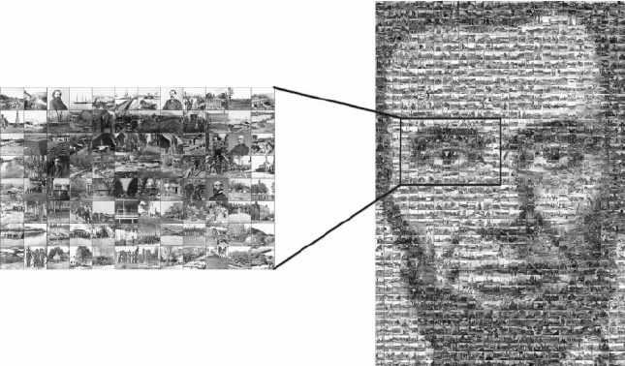

5. Characteristics
- Hides the existence of data.
- Uses a cover object.
- Difficult to detect.
- Can be combined with cryptography.
- Does not significantly change the cover file.
- Supports multiple media types.
- Provides confidentiality and secrecy.

6. Features
- Invisible communication.
- Secret information remains hidden.
- High confidentiality.
- Easy digital implementation.
- Can hide text, images, audio, video, or files.
- Often combined with encryption.
- Supports digital watermarking.

7. Components of Steganography
There are five main components.
1. Secret Message
The confidential information to be hidden.
Example
Meet at 6 PM

2. Cover Object
The original file used to hide the message.
Examples
- Image
- Audio
- Video
- Text
- PDF

3. Stego Key (Optional)
A secret password used during embedding and extraction.
Example
Password123

4. Embedding Algorithm
The algorithm that hides the message inside the cover object.

5. Stego Object
The final output after embedding.
Original Image

↓

Embedding

↓

Stego Image
The Stego Image looks almost identical to the original image.

9. Types of Steganography
There are five major types.

Type 1: Text Steganography
Definition
Secret information is hidden inside text.
Methods include:
- Extra spaces
- Invisible characters
- Capitalization patterns
- Line shifting
Example
Normal
HELLO FRIEND
Hidden version
HELLO FRIEND
(Double space may represent binary 1.)

Advantages
- Very simple
- Small file size
Disadvantages
- Easy to detect
- Low capacity

Type 2: Image Steganography
Definition
Secret data is hidden inside digital images.
This is the most common type.
Popular image formats:
- BMP
- PNG
- JPEG

Working
Pixels contain RGB values.
Example
Original Pixel
10110010
After hiding one bit
10110011
Only the last bit changes.
Human eyes cannot notice the difference.

Common Technique
LSB (Least Significant Bit)
The least significant bit of pixel values is modified.

Advantages
- High hiding capacity
- Excellent visual quality
- Most popular

Disadvantages
- Compression may destroy hidden data.

Type 3: Audio Steganography
Definition
Secret information is hidden inside audio files.
Formats:
- WAV
- MP3
- AAC
Methods:
- LSB modification
- Echo hiding
- Phase coding

Example
Original audio
Music.wav
↓
Hidden message inserted
↓
Output audio sounds almost identical.

Type 4: Video Steganography
Definition
Secret data is hidden inside video files.
Video combines:
- Images
- Audio
- Frames
Thus, it provides very high hiding capacity.
Formats
- MP4
- AVI
- MKV

Advantages
- Very high capacity
- Difficult to detect

Disadvantages
- Large file size
- Higher processing time

Type 5: Network Steganography
Definition
Secret information is hidden inside network packets.
Hidden in:
- TCP headers
- IP headers
- Packet timing
- Protocol fields
Used for covert communication.

10. Steganography Process
Secret Data

↓

Choose Cover Object

↓

Embedding Algorithm

↓

Stego Object

↓

Transmission

↓

Extraction

↓

Original Message

11. Image Steganography Example (LSB)
Suppose pixel value is
10010110
Need to hide binary
1
Modify last bit
10010111
Difference
Only one bit changed.
Image quality remains almost unchanged.

12. Text Example
Original Text
HELLO WORLD
Hidden version
HELLO WORLD
(Double spaces may encode binary values.)

13. Audio Example
Original Audio
Song.mp3
↓
Modify LSB of audio samples
↓
Output
Song.mp3
Listeners hear no noticeable difference.

14. Video Example
Original Video
Movie.mp4
↓
Hide message in video frames
↓
Output
Movie.mp4
The video appears unchanged.

15. Network Example
Secret message hidden inside
- TCP sequence numbers
- IP identification field
- Packet timing
Receiver extracts the hidden information.

16. Advantages
- Hides the existence of information.
- Difficult to detect.
- Supports multiple media types.
- High confidentiality.
- Can be combined with cryptography.
- Suitable for digital watermarking.
- Protects copyright information.

17. Disadvantages
- Hidden data may be destroyed by compression.
- Limited storage capacity in some media.
- Advanced steganalysis tools can detect hidden data.
- Large files require more processing.
- Not a replacement for encryption.

18. Applications
- Military communication
- Digital watermarking
- Copyright protection
- Secure communication
- Medical record protection
- Intelligence agencies
- Cloud security
- Digital forensics
- Banking and financial systems

19. Steganography vs Cryptography
Feature | Steganography | Cryptography
Purpose | Hide existence of message | Hide meaning of message
Visibility | Message is invisible | Message is visible but unreadable
Output | Stego Object | Ciphertext
Detection | Difficult | Easy to know encryption exists
Security | Hiding | Encryption
Uses Key | Optional | Required
Example | Hidden message in image | AES, RSA

20. Steganography vs Watermarking
Feature | Steganography | Watermarking
Purpose | Secret communication | Ownership verification
Data Hidden | Secret message | Copyright information
Visibility | Hidden | Hidden or Visible
Main Goal | Confidentiality | Authentication
Application | Secure communication | Copyright protection

21. Steganography vs Digital Watermarking vs Cryptography
Feature | Steganography | Watermarking | Cryptography
Hides Data | Yes | Yes | No
Hides Existence | Yes | No | No
Encrypts Data | Optional | No | Yes
Main Purpose | Secret Communication | Ownership | Data Security
Example | Hidden text in image | Company Logo | AES Encryption

22. Real-Life Examples
Example 1 – Military Communication
A confidential military message is hidden inside a satellite image and sent to another location. Anyone intercepting the image sees only an ordinary photograph.

Example 2 – Copyright Protection
Photographers embed invisible copyright information inside digital photographs to prove ownership if the image is copied.

Example 3 – Medical Records
Patient information can be hidden inside medical images (such as X-rays or MRI scans) so that both the image and the associated patient data remain together securely.

Example 4 – Digital Banking
Banks can embed transaction identifiers or authentication information inside digital documents to verify authenticity.

